1/4/2026
DSA LAB PROJECT
EVENT MANAGEMENT SYSTEM
Muhammad Ali and Hafiz Danial Ahmed Khan

📘 DATA STRUCTURES FINAL PROJECT REPORT

Project Title
University Event Management System (Nexus-Style) Using Data Structures

Course Information
- Course Name: Data Structures Lab
- Program: BSCS / BSIT (3rd Semester)
- Semester: Spring 2025
- Course Outcome (CLO-3):
Design and implement a fully working console-based application using multiple data structures to solve a real-world problem efficiently.

Group Members
- Muhammad Ali –241896
- Hafiz Danial Ahmed Khan – 241881

1. Introduction / Background
Managing large university events such as Nexus involves handling multiple activities, including event scheduling, participant registration, prioritization of VIP participants, tracking event modules, and maintaining records efficiently. Manual management of such systems is time-consuming and error-prone.
This project implements a University Event Management System using Data Structures in C++, providing an efficient, modular, and scalable solution for managing events, participants, and system workflows.

2. Problem Statement
The problem addressed in this project is the inefficient manual handling of event registrations, scheduling, prioritization, and record maintenance during large-scale university events. There is a need for a system that can:
- Manage multiple events and modules
- Handle participant registrations efficiently
- Prioritize VIP registrations
- Track event workflows and dependencies
- Provide fast searching and analytics
- Store and retrieve data permanently

3. Objectives
The main objectives of this project are:
- To design a menu-driven console application in C++
- To apply multiple data structures in a real-world scenario
- To efficiently manage event registration and verification
- To demonstrate insert, delete, search, and traversal operations
- To implement file handling for permanent data storage
- To visualize relationships using a graph-based module

4. Scope of the Project
The system supports:
- Event creation, update, deletion, and search
- Participant registration (normal and VIP)
- Priority-based registration handling
- Event capacity management
- Graph-based visualization of event modules
- Data analytics and reporting
- Permanent storage using files

5. System Architecture
The system is designed using Object-Oriented Programming (OOP) principles and consists of the following core components:
- Participant Management
- Event Management
- Registration Processing
- Data Analytics
- Graph-Based Network Module
- File Handling Module
Each component is implemented using appropriate data structures to ensure efficiency and clarity.

6. Data Structures Used and Justification
Data Structure | Purpose | Justification
Linked List (Custom) | Queue & Stack implementation | Efficient dynamic insertion and deletion
Queue | Pending registrations | FIFO order suits the registration workflow
Priority Queue (Heap) | VIP registrations | Ensures high-priority users are processed first
Stack | Verified registrations & undo | LIFO behavior for undo operations
Binary Search Tree (BST) | Event storage | Sorted event management and fast searching
Hash Table | Participant lookup by CNIC | O(1) average-time search
Graph (Adjacency List) | Event-module relationships | Visualizes event dependencies

7. Mandatory System Modules (As Required)

7.1 Core Record Management
- Add, update, delete, search, and display events and participants
- Data Structures Used: BST, Hash Table

7.2 Task & Process Handling
- Participant registration workflow
- Data Structure Used: Queue, Priority Queue

7.3 Hierarchical / Organized Storage
- VIP prioritization and popular events
- Data Structure Used: Priority Queue (Heap)

7.4 Smart Search & Analytics
- Fast participant lookup
- Most popular event
- Revenue calculation
- Data Structures Used: Hash Table, Stack

7.5 Relationship / Network Module
- Event-module network visualization
- BFS and DFS traversal
- Data Structure Used: Graph (Adjacency List)

7.6 Log & Activity Tracking
- Verified registration history
- Undo last verification
- Data Structure Used: Stack

8. File Handling & Data Persistence
The system uses file handling to ensure permanent data storage:
File Name | Purpose
events.txt | Stores all event records
pending.txt | Stores pending registrations
verified.txt | Stores verified registrations
- Data is loaded at system startup
- Data is saved on system exit

9. Functional Features
- Menu-driven user interface
- Registration with validation
- Event capacity enforcement
- VIP priority handling
- Undo verification
- Graph visualization
- Analytics report generation

10. Time & Space Complexity Analysis (Brief)
- BST Search: O(log n) average
- Queue Operations: O(1)
- Stack Operations: O(1)
- Hash Table Lookup: O(1) average
- Graph Traversal (BFS/DFS): O(V + E)

11. Testing & Demonstration
The system was tested using:
- 50+ participant records
- Multiple events across modules
- Registration verification and undo
- Graph traversal demonstrations
- File save/load operations

12. Limitations
- Console-based interface only
- No GUI or web support
- Static graph size
- Manual date entry

13. Future Improvements
- GUI or web-based interface
- Dynamic graph creation
- Online payment integration
- Admin authentication system
- Database integration

14. Conclusion
The University Event Management System successfully demonstrates the practical application of Data Structures in solving a real-world problem. The project fulfills all course requirements, integrates multiple data structures efficiently, and provides a scalable and modular solution suitable for university-level event management.

15. Flowchart
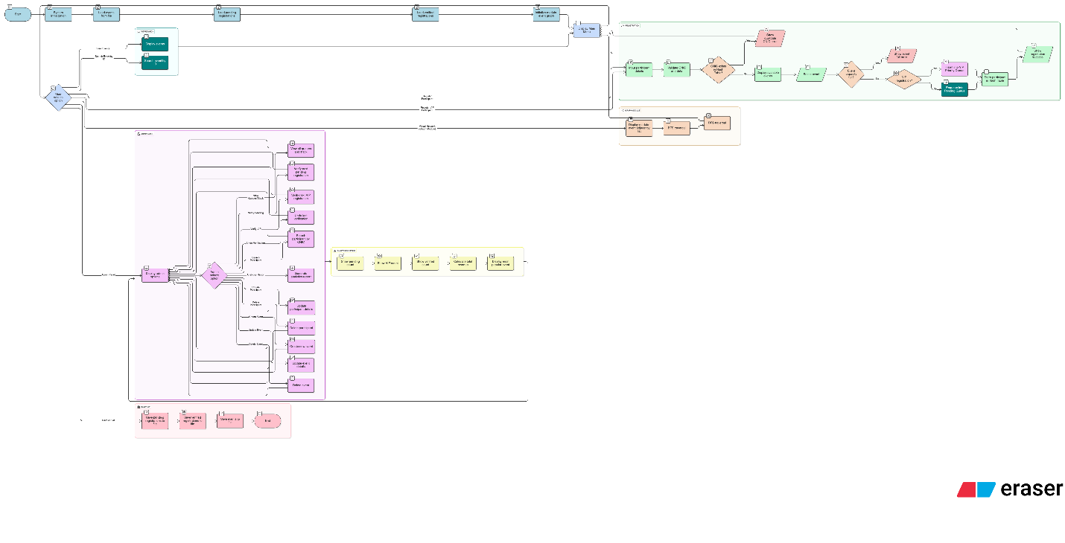

Screenshots of outputs
